A direct-current (DC) generator is a rotating machine that supplies an electrical output with unidirectional voltage and current. The basic principles of operation are the same as those for synchronous generators……**TYPES** They are Permanent Magnet DC generator, Separately Excited DC generator, and Self-Excited DC generator**…….basic parts of dc generator….** Stator. …Rotor. ……Armature Windings. .......Yoke. .......Poles. .......Pole Shoe. ......Commutator. .....Brushes….**WORKING PRINCIPLE**….A DC generator operates on the principle of Faraday’s laws of electromagnetic induction. According to Faraday’s law, whenever a conductor is placed in a fluctuating magnetic field (or when a conductor is moved in a magnetic field) an EMF is induced in the conductor. …..**E.M.F Equation of DC generator**……dc generator Z, P and A are constant so that **Eg ∝ Nϕ**. Z is the total number of armature conductor……P is the number of poles in a generator……A is the number of parallel lanes within the armatur …..N/60 is the number of turns per second**Applications of DC Generators**

The separately excited type DC generators are used for power and lighting purposes…….The series DC generator is used in arc lamps for lighting, stable current generator and booster…….DC generators are used to reimburse the voltage drop within Feeders……DC generators are used to provide a power supply for hostels, lodges, offices, etc.

**2.CB**  This configuration provides very low input impedance(only 50 to 500 ohm)…… It provides very high output impedance(1 to 10 Mega Ohm)…… less than unity(0.95 to 0.99)…… In this configuration the output signal always in the same phase with the input signal.**APPLICATIONS**….. Transistor CB configuration used in current to voltage converter circuits…**…** This configuration used in very high-frequency applications.  
**2.1..CE** This configuration provides medium input impedance(500 ohm to 5000 ohm)…. It provides very high output impedance(50 to 500 kilo Ohm)……between 35 to 500….. In this configuration, the phase difference between output and input signal is 180 degrees out of phase**.APPLICATIONS**….. CE configuration is used RF signal processing circuits**…..** This configuration is used for audio amplifier circuits……**.** This configuration is used in sensor controller circuits

**2.3CC 1.** This configuration provides very high input impedance(200 to 750 kilo Ohm)….. It provides very low output impedance(up to 50 Ohm)….. In this configuration, the output signal always in the same phase with the input signal.**APPLICATIONS** Transistor CC configuration is used for switching purposes…… This configuration is used for impedance matching

|  |  |  |  |
| --- | --- | --- | --- |
| **Characteristics** | **CB** | **CE** | **CC** |
| **Common Terminal for Input and Output** | Base Terminal | Emitter Terminal | Collector Terminal |
| **Input voltage applied between** | Emitter and Base terminal | Base and Emitter Terminal | Base and Collector Terminal |
| **Output Voltage taken across** | Collector and Base Terminal | Collector and Emitter Terminal | Emitter and Collector Terminal |
| **Input Impedance** | Very Low(only 50 to 500 ohm) | Medium(500 to 5000 ohm) | Very high(200 to 750 kilo ohm) |
| **Output Impedance** | Very High(1 to 10 Mega Ohm) | Medium(50 to 500 kilo ohm) | Very Low( up to 50 ohm) |
| **Input Current** | Emitter Current or IE | Base Current or IB | Base Current or IB |
| **Output Current** | Collector Current or IC | Collector Current or IC | Emitter Current or IE |
| **Output Signal Phase** | Same phase with input | 180 degree out of phase | Same phase with input |
| **Current Gain** | Always less than Unity  α = IC/IE | Between 35 to 500  β = IC/IB | Very High  γ = IE/IB |
| **Voltage Gain** | About 150 | About 500 | Less Than Unity |
| **Leakage Current** | Very Small | Very Large | Very Large |
| **Power Gain** | Medium | High | Medium |
| **Application** | High Frequency Circuits | RF Signal Processing | Switching Circuits |

| **Parameter** | **PN Junction Diode** | **Zener Diode** |
| --- | --- | --- |
| Definition | A two-terminal semiconductor device formed by joining a p-type semiconductor with an n-type semiconductor by alloying is known as PN junction diode. | A Zener diode is a special type of two terminal semiconductor device which is optimized to work in breakdown region. |
| Doping level of p-type & n-type semiconductors | The level of doping of p-type and n-type semiconductors used for constructing PN junction diode is low. | The highly doped p-type and n-type semiconductors are used for making Zener diode. |
| Width of depletion layer | As the PN junction diode has low doping level, thus the width of its depletion layer is more. | The Zener diode is highly doped, hence its depletion region is narrow. |
| Effect of reverse current | The high reverse current can damage the PN junction diode. | The Zener diode does not get damaged by the reverse current. |
| Breakdown voltage | In case PN junction diode, the breakdown voltage is high. | The Zener diode has relatively lower breakdown voltage. |
| Biasing condition | The PN junction diode is designed to operate in forward bias only, i.e. current flows from anode to cathode. | The Zener diode is mainly designed to operate in reverse biased conditions. |
| Ohm’s law | The PN junction obeys Ohm’s law. | The Zener diode does not obey Ohm’s law. |
| Manufacturing materials | The PN junction diode is generally made by silicon and germanium. Silicon is extensively used. | The material used for making the Zener diode is selected according to the required voltage. |
| Current flow | In PN junction diode, the current flows only in one direction (or forward direction). | In case of Zener diode, current can flow in both directions. |
| Behave in forward & reverse bias | A forward biased ideal PN junction diode acts a closed switch while in the reverse bias acts as an open switch, i.e. do not conduct. | Zener diode acts as a normal PN junction diode in the forward bias condition, but it also conducts in the reverse bias condition. |
| Application | The PN junction diode extensively used in rectification, clamping, clipping, etc. | The Zener diode is mainly used as a voltage regulator (or stabilizer) in the electronic devices and circuits. |

| S.No. | Parameters | Half Adder | Full Adder |
| --- | --- | --- | --- |
| 1. | Description | Half Adder is a combinational logic circuit that adds two 1-bit digits. The half adder produces a sum of the two inputs. | A full adder is a combinational logic circuit that performs an addition operation on three one-bit binary numbers. The full adder produces a sum of the three inputs and carry value. |
| 2. | Previous carry | The previous carry is not used. | The previous carry is used. |
| 3. | Inputs | In Half adder, there are two input bits ( A, B). | In full adder, there are three input bits (A, B, C-in). |
| 4. | Outputs | The generated output is of two bits-Sum and Carry from the input of 2 bits. | The generated output is of two bits-Sum and Carry from the input of 3 bits. |
| 5. | Used as | A half adder circuit cannot be used in the same way as a full adder circuit. | A full adder circuit can be used in place of a half adder circuit. |
| 6. | Feature | It is simple and easy to implement | The design of a full adder is not as simple as a half adder. |
|  |  |  |  |
| 8. | Logic gates | It consists of one EX-OR gate and one AND gate. | It consists of two EX-OR, two AND gates, and one OR gate. |
| 9. | Applications | It is used in Calculators, computers, digital measuring devices, etc. | It is used in Multiple bit addition, digital processors, etc. |

Electrical Wiring is a process of connecting cables and wires to the related devices such as fuse, switches, sockets, lights, fans etc to the main distribution board is a specific structure to the utility pole for continues power supply…..Joint box system or Tee system….Loop – in system**….Different Types of Electrical Wiring Systems….**The types of internal wiring usually used are**…..Cleat wiring….Wooden casing and capping wiring….CTS or TRS or PVC sheath wiring…..Lead sheathed or metal sheathed wiring….Conduit wiring….**

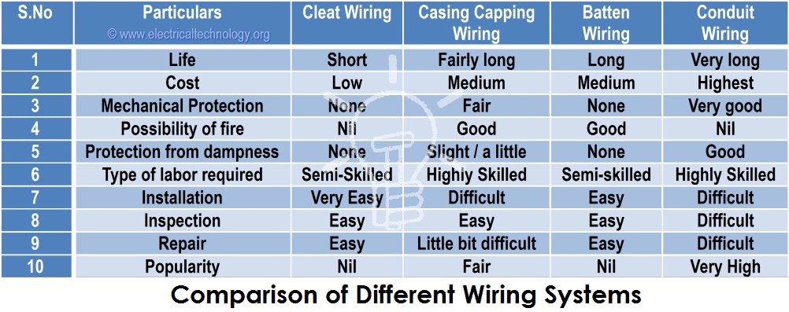

|  |  |  |
| --- | --- | --- |
| ***Battery Type*** | ***Characteristics*** | ***Applications*** |
| Alkaline (Zn/Alkaline/MnO2) | Very popular, moderate cost, high performance | Most popular primary batteries |
| Magnesium (Mg/MnO2) | High capacity, long shelf life | Military and aircraft Radios |
| Mercury (Zn/HgO) | Very high capacity, long shelf life | Medical (hearing aids, pacemakers), photography |
| Lithium/Solid Cathode | High energy density, low temp performance, long shelf life | Replacement for button and cylindrical cells |
| Lithium/Soluble Cathode | High energy density, good performance, wide temp range | Wide range of applications with a capacity between 1 – 10,000 Ah |
| Lithium/Solid Electrolyte | Low power, extremely long shelf life | Memory circuits, medical electronics |
| Silver/Zinc (Zn/Ag2O) | Highest capacity, costly, flat discharge | Hearing aids, photography, pagers |
| Zinc – Carbon | Common, low cost, variety of sizes | Radios, toys, instruments |